**Confirmation Preparation Sessions 2023-2024**

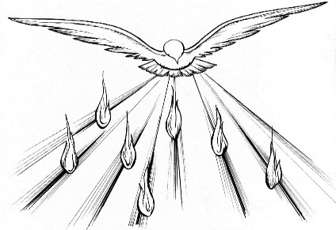

**Wednesday September 28, 7pm** (arrival at 6:45pm)

Prayer Service in the Church

Enrollment Ceremony and Meeting

**Monday, October 23, 7pm** (arrival at 6:45pm)

Mass and Novena Prayers in the Church

Meeting in the Parish Hall

**Tuesday, November 28, 7pm** (arrival 6:45)

“The Holy Spirit does not Social Distance”

Megan Callahan, Director of Youth Ministry, Diocese of Metuchen

**Sunday, December 3, 4pm (arrival 3:45)**

1st Sunday of Advent Holy Hour in the Church

Meeting in the Parish Hall

**Friday, December 8, 7pm** (arrival at 6:45)

Retreat with Colleen Kelly of CKR Retreats in Parish Hall

Confirmation Candidates and an Adult to attend (Sponsor or Parent)

**Monday January 22, 7pm** (arrival at 6:45)

Sister Anna and Students of the Rutgers Catholic Center in the Parish Hall

Diaper Drive for the Crisis Center

**Wednesday, February 21, 6:30 pm** (arrival 6:15)

Chastity and Respect Self Presentation in the Parish Hall

Presentation by Omar Fernandes, Life Net

**Friday, March 1, 7pm** (arrival at 6:45)

Lenten Mass and Stations of the Cross in the Church

Social Justice Meeting in the Parish Hall

Catholic Relief Services- Rice Bowls

**Sunday March 10, 4pm** (arrival at 3:34)

Confirmation Rehearsal and Confession

**Friday March 15, 5pm** (arrival at4:40pm)

Confirmation Mass

Bishop James Checchio